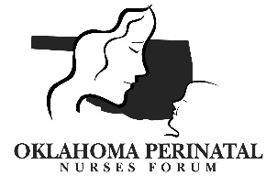

Thursday March 9, 2017, 11:30 am – 1:30 pm
Hillcrest Medical Center, Tulsa

AGENDA: Brief Business Meeting:

- Introductions/Announcements – Angela Strickland

- Speaker: Car Seat Safety, Laswanique Gray, OSDH

- Treasurer’s Report – Kathy Coble

- Professional Development Council – Denese Knori

- Oklahoma Perinatal Quality Improvement Collaborative – Barbara O’Brien

- AWHONN Officer Update -

- Discussion –
- OPNF Board positions: Secretary, Treasurer

Hosts are needed for future meeting locations! Providing Lunch is not a requirement. Please contact Angela Strickland or Vicky Harter if your hospital is interested in hosting.
- Thursday June 8, 2017: Stillwater Medical Center
- Thursday September 14, 2017 –
- Thursday December 14, 2017 -

Directions:
- Hillcrest Medical Center: 1120 S Utica Ave, Tulsa, OK 74104
- See attached map

