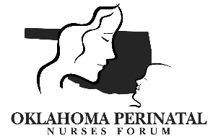

Thursday September 8, 2016, 11:30 am – 1:30 pm
Mercy Edmond I-35

AGENDA: Brief Business Meeting:

- Introductions/Announcements – Barbara Koop

- Speaker: Megan Souder, MPH, CPH, Administrator, OKC-County Health Department, topic: Zika virus

- Treasurer’s Report – Kathy Coble

- Professional Development Council – Denese Knori

- Oklahoma Perinatal Quality Improvement Collaborative – Barbara O’Brien

- AWHONN - Annette Martin

- Discussion:

Hosts are needed for future meeting locations! Providing Lunch is not a requirement. Please contact Barbara Koop or Vicky Harter if your hospital is interested in hosting.
- Thursday December 8, 2016, Christmas Meeting:
- Thursday March 9, 2017:
- Thursday June 8, 2017:

Directions: (see email attachment)
- 2017 West I-35 Frontage Road |Edmond, Oklahoma 73013
- Conference Room F

