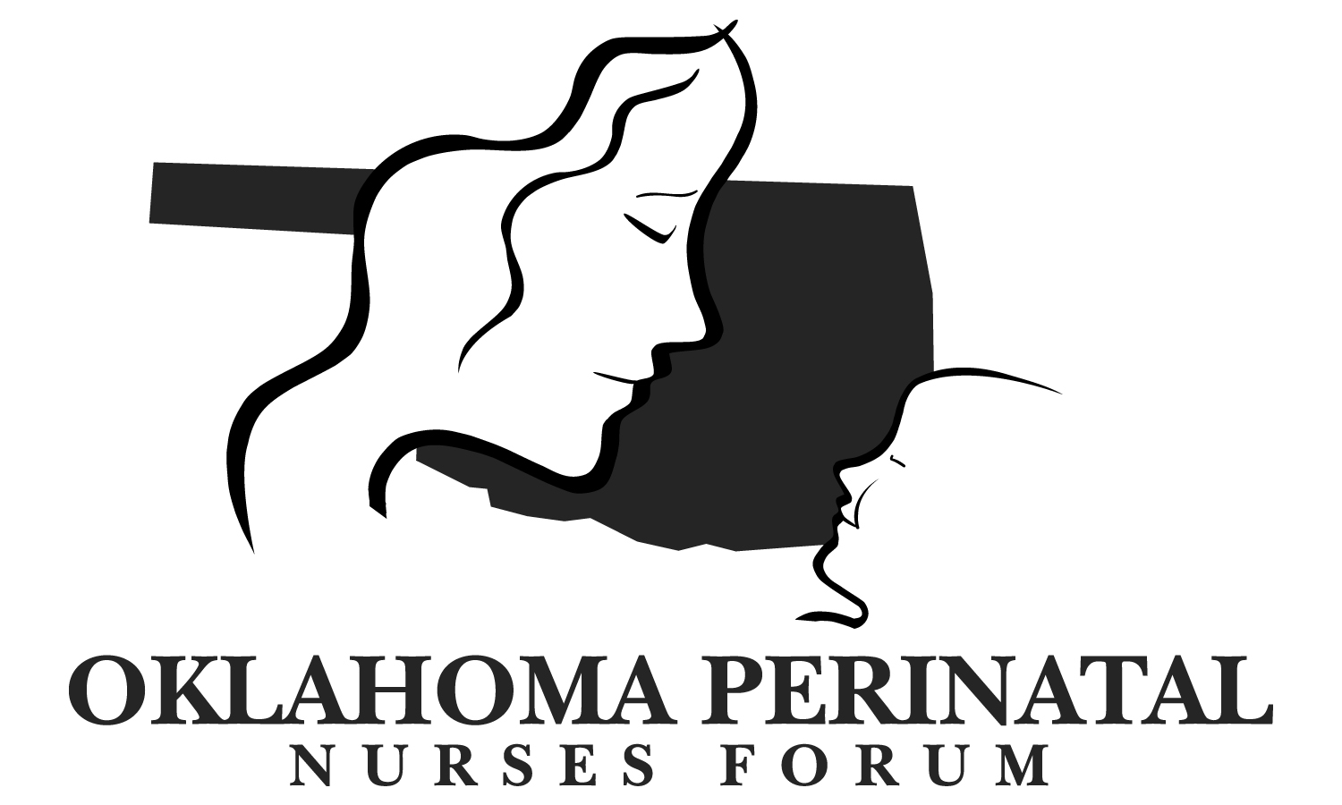

**Thursday March 10, 2016, 11:30 am – 1:00 pm**

**INTEGRIS Health Edmond**

**AGENDA: Brief Business Meeting:**

1. Introductions/Announcements – **Barbara Koop**
2. Speaker: **Christina Smith, Postpartum Depression**
3. Treasurer’s Report – **Kathy Coble**
4. Professional Development Council – **Denese Knori**
5. Reports
6. Oklahoma Perinatal Quality Improvement Collaborative – **Barbara O’Brien**
   * Every Mother Counts
   * Prematurity Prevention
   * Neonatal Infection Prevention—**Denise Cole**
7. Office of Perinatal Quality Improvement - Preparing for a Lifetime Hospital Based Activities

* Period of Purple Crying – **Barbara Koop**
* Breastfeeding – **Becky Mannel**
* Infant Safe Sleep – **Denise Cole**

1. AWHONN updates - **Annette Martin**
2. Discussion:

**Future Meeting Locations:** Providing Lunch is not a requirement. Please contact Barbara Koop or Vicky Harter if your hospital is interested in hosting

* Wednesday, June 9, 2016:
* Thursday, September 8, 2016:
* Wednesday, 14, 2016: