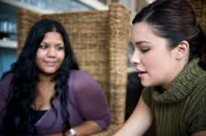

Moms Offering Moms Support (MOMS)
A support group for women experiencing Post-Partum Depression

When: Beginning Tuesday October 6, 2015
Meets every OTHER week
Group starts at 5pm

Where: Birthchoice, 4701 S.Western, OKC, OK 73109

For more information or to register for the support group,
call: 631-4477, speak with Hope or Lori

